Sky Background

The sky background is the incoming light from the sky measured on the telescope that is not from the source being observed. The amount of sky background can vary at different wavelengths and is mainly due to light diffusion by the atmosphere. There are numerous sources that contribute towards the sky background such as airglow, zodiacal light and thermal radiation.

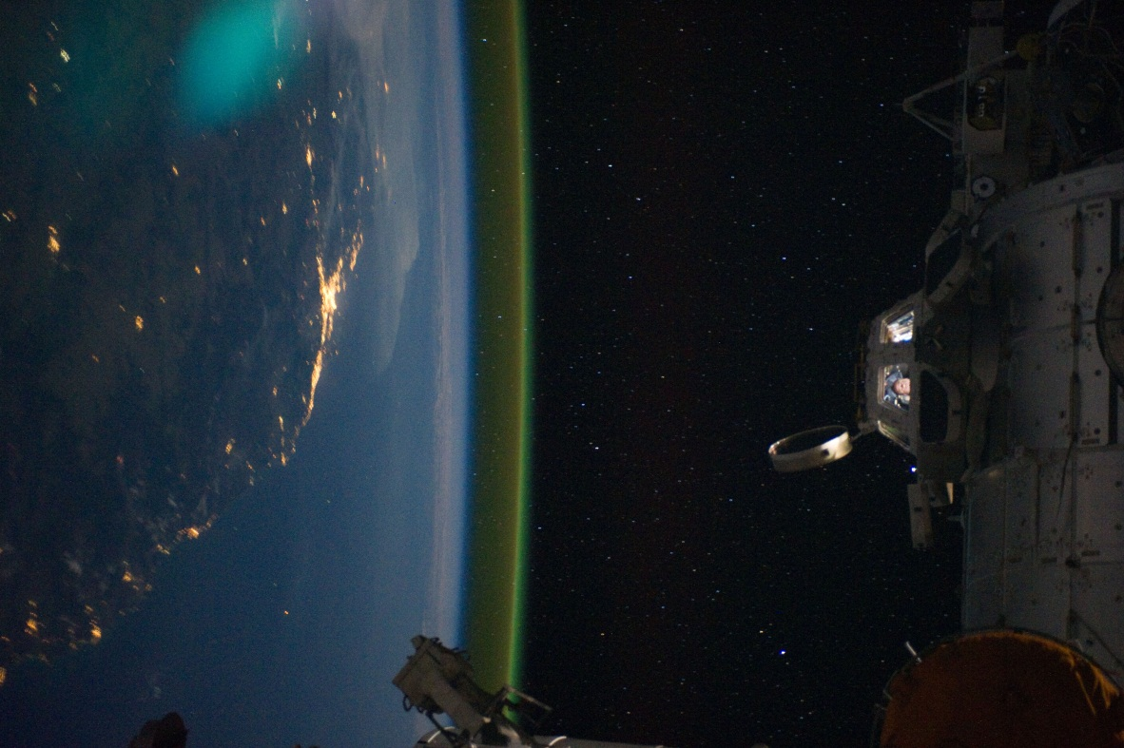Airglow is the atmospheric emission of photons at wavelengths from the near-UV to the near-IR range due to chemical reactions in the upper atmosphere [5]. These chemical reactions lead to photon emissions due to the decay of electrons from an excited state in one of the reaction products. One such example is the emission in the near infrared region by OH radicals created from a reaction between ozone and hydrogen in the upper atmosphere [6]. Other processes contributing to airglow are the recombination of ions originally ionised by the sun, and the luminescence of cosmic rays striking the upper atmosphere. Airglow therefore produces a faint glow and can be seen in figure – [7].

Figure -: An image from the International Space Station showing airglow in the upper atmosphere

Another of the contributors to the sky background is zodiacal light which is the scattering of sunlight off interplanetary dust [8]. This can be seen in figure – below. This causes a faint white glow that can be best seen before sunrise or after sunset but is generally so faint it cannot be seen over moonlight or light pollution. The dust in the solar system forms a thick lens shape cloud known as the interplanetary dust cloud or zodiacal cloud and it is off this cloud that light from the Sun is scattered. Zodiacal light is mainly seen in the ecliptic plane, the plane of the solar system, as most of the dust making up this cloud is located in this plane. Another similar effect to this is the gegenschein, or counter shine, which is a faint glow in the antisolar direction [9]. At this point, the zodiacal light is enhanced by backscattering off interplanetary dust producing a small brightening in this part of the sky.

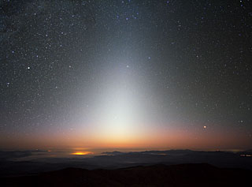

Figure -: Zodiacal light imaged at the ESO’s La Silla Observatory in Chile [10]

Background from zodiacal light can however be greatly reduced by observing outside of the ecliptic plane as this is where the flux of photons due to zodiacal light is weakest. This can be seen in figure – below which shows the flux of photons as a function of angle to the ecliptic plane.

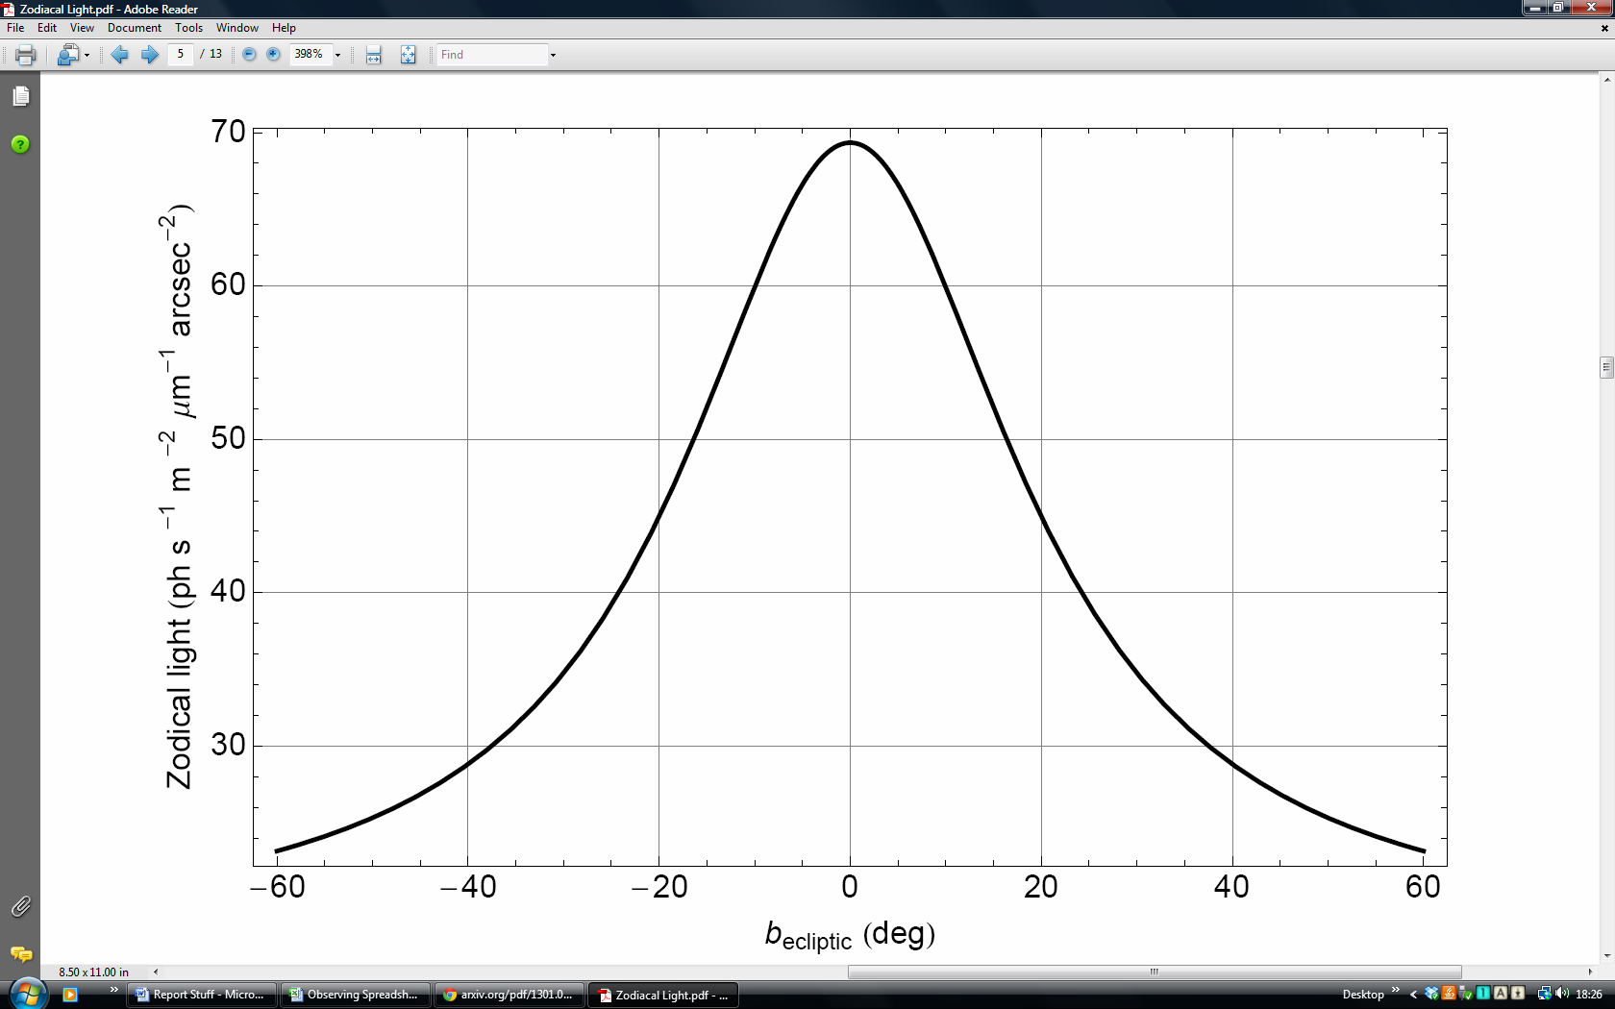

The zodiacal light is strongest at a very small angle to the ecliptic plane but significantly decreases as the angle increases and so viewing well outside the ecliptic plane should considerably reduce background from zodiacal light.

Thermal radiation in the atmosphere by greenhouse gases also contributes to the sky background and is due to the absorption and emission of radiation from the Sun into the atmosphere in the mid-IR region. In this case, observations in the mid- and far-IR region must be carried out from outside the atmosphere [12]. The sky background is therefore primarily an issue for ground based telescopes as they can incur a large background number of photons compared to the number of photons arriving from the source being observed.

As space based telescopes are situated outside of the atmosphere, they avoid almost all of this background with their main source of background coming in the form of zodiacal light or thermal background due to radiation from the Sun. This can be calculated by first determining the number of photons from this thermal background before converting to a noise represented by the number of electrons excited in the CCD. The number of photons ( $N_{γ })$ can be calculated using the following formula:

$$N_{γ }= \frac{2k^{3}T^{3}ε}{h^{3}c^{2}} [e^{-x}\left(x^{2}+ 2x+2\right)]_{x_{1}}^{x_{2}}$$

Where $x= \frac{hν}{kt}$, ν is frequency, *k* is the Boltzmann constant, *t* is temperature, *h* is Planck’s constant, *c* is the speed of light and ε is the emissivity. *X1* is the bluer end of the filter, i.e. the shorter wavelength whilst *x2* is the redder end of the filter, i.e. the longer wavelength. The full derivation of this can be seen in appendix- (ENTER APPENDIX NUMBER HERE). This can then be used to calculate the number of electrons per second per pixel ($N_{e}$) on the CCD contributing towards the background via the following formula:

$$N_{e}= N_{γ}Aε_{th}Ω_{pix}$$

Where A is the collecting area of the telescope, $ε_{th}$ is the throughput of the filter used and $Ω_{pix}$ is the solid angle subtended by each pixel in steradians. Completing this calculation for the Hubble Space telescope gives a value of $N_{e}$ of 0.02electrons/second/pixel. Whilst this is not the dominant source of background for the Hubble telescope, this may be used to calculate a rough estimate of the thermal background of other space based telescopes such as Euclid and JWST which are located at the second Lagrange point, well away from any atmospheric background.

1. An atmospheric radiation model for Cerro Paranal, page 9
2. A method to remove residual OH emission from near infrared spectra, R. I. Davies, page 1
3. http://spaceflight.nasa.gov/gallery/images/station/crew-28/html/iss028e050185.html,2011
4. The nature of the near-infrared interline sky background using ﬁbre Bragg grating OH suppression, NAMES, pages 5-6, 2013
5. High-resolution Imaging of the Gegenschein and the Geometric Albedo of Interplanetary Dust, NAMES, 2013
6. http://www.eso.org/public/images/zodiacal_beletsky_potw/
7. Extragalactic Astronomy and Cosmology, Peter Schneider, pages 22-23
8. Diffraction-Limited Imaging with Large and Moderate Telescopes, Swapan K Saha, pg 188

Astronomical Seeing

Plane waves from a source being observed are distorted by the Earth’s atmosphere and so upon reaching a telescope within the atmosphere are slightly perturbed and the image formed, blurred. This effect is contributed to by numerous layers where different temperatures or the interaction of different wind speed causes this effect with ‘Seeing’ the term used to describe the total distortion of the wavefront [13]. This effect is shown below in figure # where a turbulent layer of the atmosphere causes a change in the shape of the wavefront.